Name | ID | STUDENT SIGN
MD. SHOHANUR RAHMAN SHOHAN | 22-46013-1 | 
Instructions:
- Make sure to write your Name, ID and Signature on this document.
- First write your signature on a paper then take photo of that signature and use it for signing this document.
- After completing the requirements of the midterm assignment by editing this document, upload this document in the link provided in your VUES Student Account.

Midterm Assignment
- Below a scenario has been given draw the ER Diagram.
Draw with proper annotations (use DIA, VISIO, MS WORD etc.). For reference see ERDiagramTutorial.
In a doctor appointment management system, a patient takes appointment from a doctor and a doctor attend appointment of many patients. A doctor is identified by doctor id, name, address, room no, qualification, specialty, visit, and contact no. There may be multiple contact no of a doctor. A Patient is identified by their unique ID and the system stores their name, mobile number, age and address. A patient address is composed of city name, street number, and house number. One doctor can be associated with many chambers, but one chamber is associated with only one doctor and the system stores the id and address of each chamber, including the city name, street number, and house number. Additionally, one doctor has many compounders, but a compounder is associated with only one doctor and a compounder is identified by their ID, name, and contact numbers. A chamber is maintained by only one compounder and a compounder maintain only one chamber. While taking appointment, the date and time of appointment for each patient is also stored. Furthermore, one doctor can have many schedules, but each schedule is associated with only one doctor and the system stores the id, time and date for each schedule and a compounder can manage many schedules for doctor, but a schedule is managed by one compounder.

Answer 1:
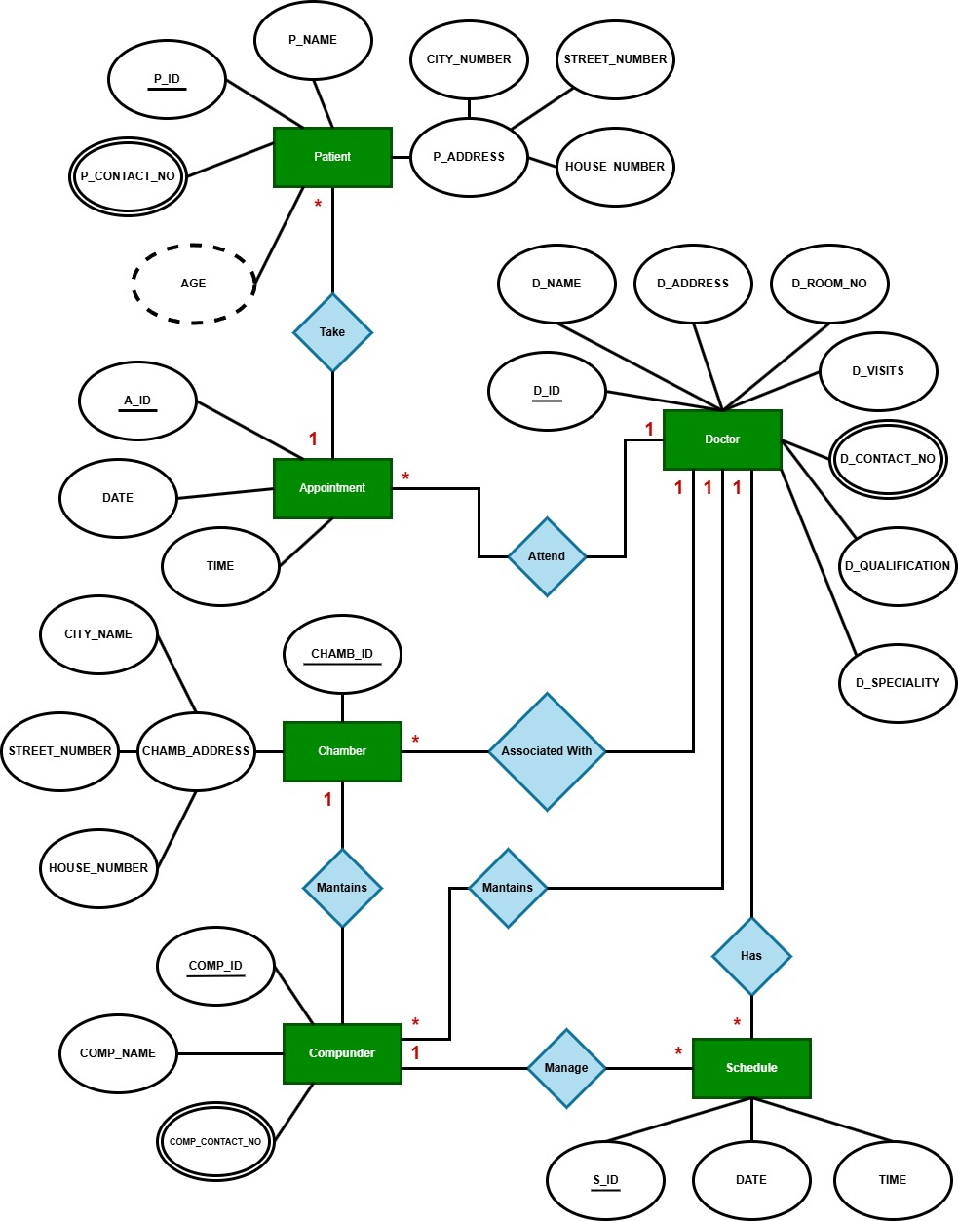

- Below an ER Diagram has been given write the scenario.
For reference see ERDiagramTutorial.
- Below an ER Diagram has been given write the scenario.
For reference see ERDiagramTutorial.

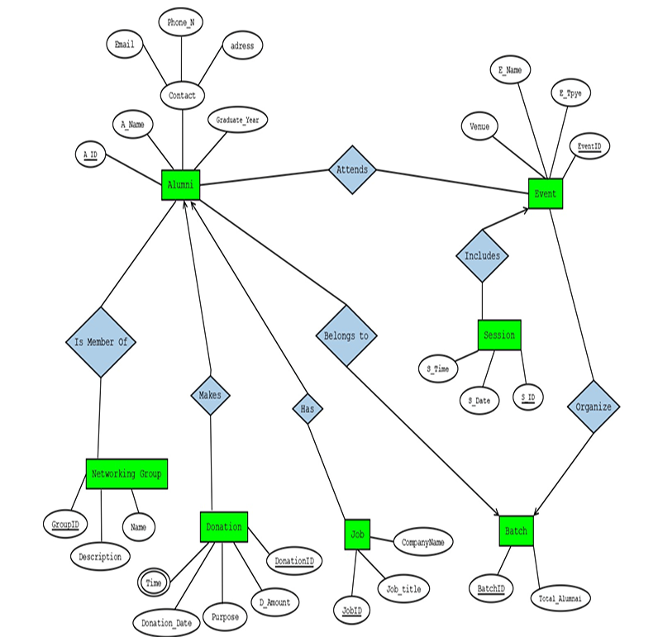

Answer 2:
The Alumni Relationship Management System is built to keep track of alumni details, their engagement with the institution through events, donations, career progression, networking groups, and their original graduating batches. Each alumnus is uniquely identified by an alumni id. Alongside their name and graduation year, the system also manages their contact information, which includes email, phone number, and address. Alumni are linked to a specific batch, and each batch is represented by a unique batch id and records the total number of alumni who graduated in that group. While an alumnus belongs to exactly one batch, each batch can be associated with multiple alumni. To maintain continued interaction, batches are responsible for organizing events. Each event, identified by event id, carries a name, type (like seminar, reunion, etc.), and a venue. Since events can be of interest to multiple groups, they may be organized by multiple batches. Alumni can attend events, and these events may have multiple alumni participants, forming a many-to-many relationship. Events are structured into one or more sessions, and each session, marked with a session id, includes a date and time. Every session is part of exactly one event. To support institutional initiatives, alumni may make donations. A donation is uniquely tracked using donation id, and includes details such as the amount, purpose, date, and a time attribute, which might represent different stages or timestamps. Alumni may also be active in various networking groups. Each group, recognized by group id, includes a name and a description. Alumni can be members of multiple groups, and each group may include many alumni another many-to-many relationship. Additionally, alumni may have pursued various jobs after graduation. Each job is captured with a job id and includes the job title and the company name. An alumni can have multiple jobs over time, reflecting their career journey.

- Normalize the ER Diagram given below up to 3rd Normal Form and finalize the tables that needs to be created. Then (in Oracle using SQL) write down the queries that are required to create all the tables with necessary constraints. Also insert at least 3 rows of data in each created table.
For reference see NormalizationTutorial and BasicSQLTutorial.

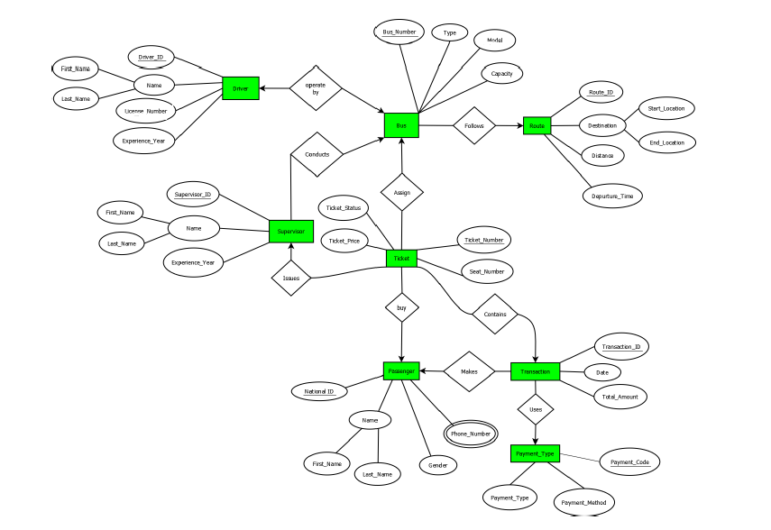

Answer Box (Normalization steps in detail as shown in Normalization Tutorial Slide + all the queries required to create the tables and insert data after Normalization):
Solution:
Step – 1: Analyze the Entity Relationship Diagram
Entity | Attributes
DRIVER | DRIVER_ID (PK), FIRST_NAME, LAST_NAME, LICENSE_NUMBER, EXPERIENCE_YEAR
BUS | BUS_NUMBER (PK), TYPE, MODEL, CAPACITY
ROUTE | ROUTE_ID (PK), START_LOCATION, END_LOCATION, DISTANCE, DEPARTURE_TIME
TICKET | TICKET_NUMBER (PK), TICKET_STATUS, TICKET_PRICE, SEAT_NUMBER
SUPERVISOR | SUPERVISOR_ID (PK), FIRST_NAME, LAST_NAME, EXPERIENCE_YEAR
PASSENGER | NATIONAL_ID (PK), FIRST_NAME, LAST_NAME, PHONE_NUMBER, GENDER
TRANSACTION | TRANSACTION_ID (PK), DATE, TOTAL_AMOUNT
PAYMENT_TYPE | PAYMENT_CODE (PK), PAYMENT_METHOD, PAYMENT_TYPE

Relations
OPERATED BY | FOLLOWS | CONDUCTS | ASSIGN | ISSUES | BUY | CONTAINS | MAKES | USES

Step – 2: Normalization (UNF, 1NF, 2NF, 3NF)
OPERATED BY
UNF:
DRIVER_ID, FIRST_NAME, LAST_NAME, LICENSE_NUMBER, EXPERIENCE_YEAR, BUS_NUMBER, TYPE, MODEL, CAPACITY
1NF: NO multivalued attribute. (SAME AS UNF)
DRIVER_ID, FIRST_NAME, LAST_NAME, LICENSE_NUMBER, EXPERIENCE_YEAR, BUS_NUMBER, TYPE, MODEL, CAPACITY
2NF:
- DRIVER_ID, FIRST_NAME, LAST_NAME, LICENSE_NUMBER, EXPERIENCE_YEAR, BUS_NUMBER
- BUS_NUMBER, TYPE, MODEL, CAPACITY
3NF:
- DRIVER_ID, LICENSE_NUMBER, EXPERIENCE_YEAR, BUS_NUMBER, NAME_ID
- NAME_ID, FIRST_NAME, LAST_NAME
- BUS_NUMBER, TYPE, MODEL, CAPACITY

FOLLOWS
UNF:
BUS_NUMBER, TYPE, MODEL, CAPACITY, ROUTE_ID, START_LOCATION, END_LOCATION, DISTANCE, DEPARTURE_TIME
1NF: NO multivalued attribute. (SAME AS UNF)
BUS_NUMBER, TYPE, MODEL, CAPACITY, ROUTE_ID, START_LOCATION, END_LOCATION, DISTANCE, DEPARTURE_TIME
2NF:
- BUS_NUMBER, TYPE, MODEL, CAPACITY, ROUTE_ID
- ROUTE_ID, START_LOCATION, END_LOCATION, DISTANCE, DEPARTURE_TIME
3NF:
- BUS_NUMBER, TYPE, MODEL, CAPACITY, ROUTE_ID, DES_ID
- DES_ID, START_LOCATION, END_LOCATION
- ROUTE_ID, DISTANCE, DEPARTURE_TIME
CONDUCTS
UNF:
BUS_NUMBER, TYPE, MODEL, CAPACITY, SUPERVISOR_ID, FIRST_NAME, LAST_NAME, EXPERIENCE_YEAR
1NF: NO multivalued attribute. (SAME AS UNF)
BUS_NUMBER, TYPE, MODEL, CAPACITY, SUPERVISOR_ID, FIRST_NAME, LAST_NAME, EXPERIENCE_YEAR
2NF:
- BUS_NUMBER, TYPE, MODEL, CAPACITY, SUPERVISOR_ID
- SUPERVISOR_ID, FIRST_NAME, LAST_NAME, EXPERIENCE_YEAR
3NF:
- BUS_NUMBER, TYPE, MODEL, CAPACITY, SUPERVISOR_ID, NAME_ID
- SUPERVISOR_ID, EXPERIENCE_YEAR
- NAME_ID, FIRST_NAME, LAST_NAME
ASSIGN
UNF:
BUS_NUMBER, TYPE, MODEL, CAPACITY, TICKET_NUMBER, TICKET_STATUS, TICKET_PRICE, SEAT_NUMBER
1NF: NO multivalued attribute. (SAME AS UNF)
BUS_NUMBER, TYPE, MODEL, CAPACITY, TICKET_NUMBER, TICKET_STATUS, TICKET_PRICE, SEAT_NUMBER
2NF:
- BUS_NUMBER, TYPE, MODEL, CAPACITY, TICKET_NUMBER
- TICKET_NUMBER, TICKET_STATUS, TICKET_PRICE, SEAT_NUMBER
3NF:
- BUS_NUMBER, TYPE, MODEL, CAPACITY, TICKET_NUMBER
- TICKET_NUMBER, TICKET_STATUS, TICKET_PRICE, SEAT_NUMBER

ISSUES
UNF:
SUPERVISOR_ID, FIRST_NAME, LAST_NAME, EXPERIENCE_YEAR, TICKET_NUMBER, TICKET_STATUS, TICKET_PRICE, SEAT_NUMBER
1NF: NO multivalued attribute. (SAME AS UNF)
SUPERVISOR_ID, FIRST_NAME, LAST_NAME, EXPERIENCE_YEAR, TICKET_NUMBER, TICKET_STATUS, TICKET_PRICE, SEAT_NUMBER
2NF:
- TICKET_NUMBER, TICKET_STATUS, TICKET_PRICE, SEAT_NUMBER, SUPERVISOR_ID
- SUPERVISOR_ID, FIRST_NAME, LAST_NAME, EXPERIENCE_YEAR
3NF:
- TICKET_NUMBER, TICKET_STATUS, TICKET_PRICE, SEAT_NUMBER, SUPERVISOR_ID, NAME_ID
- SUPERVISOR_ID, EXPERIENCE_YEAR
- NAME_ID, FIRST_NAME, LAST_NAME

BUY
UNF:
TICKET_NUMBER, TICKET_STATUS, TICKET_PRICE, SEAT_NUMBER, NATIONAL_ID, FIRST_NAME, LAST_NAME, PHONE_NUMBER, GENDER
1NF: PHONE is a multivalued attribute.
TICKET_NUMBER, TICKET_STATUS, TICKET_PRICE, SEAT_NUMBER, NATIONAL_ID, FIRST_NAME, LAST_NAME, GENDER
2NF:
- TICKET_NUMBER, TICKET_STATUS, TICKET_PRICE, SEAT_NUMBER, NATONAL_ID
- PHONE_ID, PHONE_NUMBER
- NATIONAL_ID, FIRST_NAME, LAST_NAME, GENDER
3NF:
- TICKET_NUMBER, TICKET_STATUS, TICKET_PRICE, SEAT_NUMBER, NATONAL_ID, PHONE_ID, NAME_ID
- PHONE_ID, PHONE_NUMBER
- NATIONAL_ID, GENDER
- NAME_ID, FIRST_NAME, LAST_NAME

CONTAINS
UNF:
TICKET_NUMBER, TICKET_STATUS, TICKET_PRICE, SEAT_NUMBER, TRANSACTION_ID, DATE, TOTAL_AMOUNT
1NF: NO multivalued attribute. (SAME AS UNF)
TICKET_NUMBER, TICKET_STATUS, TICKET_PRICE, SEAT_NUMBER, TRANSACTION_ID, DATE, TOTAL_AMOUNT
2NF:
- TICKET_NUMBER, TICKET_STATUS, TICKET_PRICE, SEAT_NUMBER, TRANSACTION_ID
- TRANSACTION_ID, DATE, TOTAL_AMOUNT
3NF:
- TICKET_NUMBER, TICKET_STATUS, TICKET_PRICE, SEAT_NUMBER, TRANSACTION_ID
- TRANSACTION_ID, DATE, TOTAL_AMOUNT

MAKES
UNF:
NATIONAL_ID, FIRST_NAME, LAST_NAME, PHONE_NUMBER, GENDER, TRANSACTION_ID, DATE, TOTAL_AMOUNT
1NF: PHONE is a multivalued attribute.
NATIONAL_ID, FIRST_NAME, LAST_NAME, GENDER, TRANSACTION_ID, DATE, TOTAL_AMOUNT
2NF:
- TRANSACTION_ID, DATE, TOTAL_AMOUNT, NATONAL_ID
- PHONE_ID, PHONE_NUMBER
- NATIONAL_ID, FIRST_NAME, LAST_NAME, GENDER
3NF:
- TRANSACTION_ID, DATE, TOTAL_AMOUNT, NATONAL_ID, PHONE_ID, NAME_ID
- PHONE_ID, PHONE_NUMBER
- NATIONAL_ID, GENDER
- NAME_ID, FIRST_NAME, LAST_NAME

USES
UNF:
TRANSACTION_ID, DATE, TOTAL_AMOUNT, PAYMENT_CODE, PAYMENT_METHOD, PAYMENT_TYPE
1NF: NO multivalued attribute. (SAME AS UNF)
TRANSACTION_ID, DATE, TOTAL_AMOUNT, PAYMENT_CODE, PAYMENT_METHOD, PAYMENT_TYPE
2NF:
- PAYMENT_CODE, PAYMENT_METHOD, PAYMENT_TYPE, TRANSACTION_ID
- TRANSACTION_ID, DATE, TOTAL_AMOUNT
3NF:
- PAYMENT_CODE, PAYMENT_METHOD, PAYMENT_TYPE, TRANSACTION_ID
- TRANSACTION_ID, DATE, TOTAL_AMOUNT

Step – 3: Temporary Tables (All 3NF)
- DRIVER_ID, LICENSE_NUMBER, EXPERIENCE_YEAR, BUS_NUMBER, NAME_ID
- NAME_ID, FIRST_NAME, LAST_NAME
- BUS_NUMBER, TYPE, MODEL, CAPACITY
- BUS_NUMBER, TYPE, MODEL, CAPACITY, ROUTE_ID, DES_ID
- DES_ID, START_LOCATION, END_LOCATION
- ROUTE_ID, DISTANCE, DEPARTURE_TIME
- BUS_NUMBER, TYPE, MODEL, CAPACITY, SUPERVISOR_ID, NAME_ID
- SUPERVISOR_ID, EXPERIENCE_YEAR
- NAME_ID, FIRST_NAME, LAST_NAME
- BUS_NUMBER, TYPE, MODEL, CAPACITY, TICKET_NUMBER
- TICKET_NUMBER, TICKET_STATUS, TICKET_PRICE, SEAT_NUMBER
- TICKET_NUMBER, TICKET_STATUS, TICKET_PRICE, SEAT_NUMBER, SUPERVISOR_ID, NAME_ID
- SUPERVISOR_ID, EXPERIENCE_YEAR
- NAME_ID, FIRST_NAME, LAST_NAME
- TICKET_NUMBER, TICKET_STATUS, TICKET_PRICE, SEAT_NUMBER, NATONAL_ID, PHONE_ID, NAME_ID
- PHONE_ID, PHONE_NUMBER
- NATIONAL_ID, GENDER
- NAME_ID, FIRST_NAME, LAST_NAME
- TICKET_NUMBER, TICKET_STATUS, TICKET_PRICE, SEAT_NUMBER, TRANSACTION_ID
- TRANSACTION_ID, DATE, TOTAL_AMOUNT
- TRANSACTION_ID, DATE, TOTAL_AMOUNT, NATONAL_ID, PHONE_ID, NAME_ID
- PHONE_ID, PHONE_NUMBER
- NATIONAL_ID, GENDER
- NAME_ID, FIRST_NAME, LAST_NAME
- PAYMENT_CODE, PAYMENT_METHOD, PAYMENT_TYPE, TRANSACTION_ID
- TRANSACTION_ID, DATE, TOTAL_AMOUNT

Step – 4: Finalization
- DRIVER_ID, LICENSE_NUMBER, EXPERIENCE_YEAR, BUS_NUMBER, NAME_ID
- NAME_ID, FIRST_NAME, LAST_NAME
- BUS_NUMBER, TYPE, MODEL, CAPACITY, ROUTE_ID, SUPERVISOR_ID
- DES_ID, START_LOCATION, END_LOCATION
- ROUTE_ID, DISTANCE, DEPARTURE_TIME, DES_ID
- TICKET_NUMBER, TICKET_STATUS, TICKET_PRICE, SEAT_NUMBER, BUS_NUMBER, NATIONAL_ID, TRANSACTION_ID
- SUPERVISOR_ID, EXPERIENCE_YEAR, NAME_ID
- NATIONAL_ID, GENDER, PHONE_ID, NAME_ID
- TRANSACTION_ID, DATE, TOTAL_AMOUNT, NATIONAL_ID
- PAYMENT_CODE, PAYMENT_METHOD, PAYMENT_TYPE, TRANSACTION_ID
- PHONE_ID, PHONE_NUMBER

Step – 5: Table Creation:
- NAME
CREATE TABLE NAME (
NAME_ID VARCHAR2(10) PRIMARY KEY,
FIRST_NAME VARCHAR2(50) NOT NULL,
LAST_NAME VARCHAR2(50) NOT NULL
);
- PHONE
CREATE TABLE PHONE (
PHONE_ID VARCHAR2(10) PRIMARY KEY,
PHONE_NUMBER VARCHAR2(15) UNIQUE NOT NULL
);
- SUPERVISOR
CREATE TABLE SUPERVISOR (
SUPERVISOR_ID VARCHAR2(10) PRIMARY KEY,
EXPERIENCE_YEAR NUMBER NOT NULL,
NAME_ID VARCHAR2(10) NOT NULL,
FOREIGN KEY (NAME_ID) REFERENCES NAME(NAME_ID)
);

- DESTINATION
CREATE TABLE DESTINATION (
DES_ID VARCHAR2(10) PRIMARY KEY,
START_LOCATION VARCHAR2(100) NOT NULL,
END_LOCATION VARCHAR2(100) NOT NULL
);
- ROUTE
CREATE TABLE ROUTE (
ROUTE_ID VARCHAR2(10) PRIMARY KEY,
DISTANCE FLOAT NOT NULL,
DEPARTURE_TIME DATE NOT NULL,
DES_ID VARCHAR2(10) NOT NULL,
FOREIGN KEY (DES_ID) REFERENCES DESTINATION(DES_ID)
);
- BUS
CREATE TABLE BUS (
BUS_NUMBER VARCHAR2(10) PRIMARY KEY,
TYPE VARCHAR2(20) NOT NULL,
MODEL VARCHAR2(50) NOT NULL,
CAPACITY NUMBER NOT NULL,
ROUTE_ID VARCHAR2(10) NOT NULL,
SUPERVISOR_ID VARCHAR2(10) NOT NULL,
FOREIGN KEY (ROUTE_ID) REFERENCES ROUTE(ROUTE_ID),
FOREIGN KEY (SUPERVISOR_ID) REFERENCES SUPERVISOR(SUPERVISOR_ID)
);

- DRIVER
CREATE TABLE DRIVER (
DRIVER_ID VARCHAR2(10) PRIMARY KEY,
LICENSE_NUMBER VARCHAR2(20) UNIQUE NOT NULL,
EXPERIENCE_YEAR NUMBER(4) NOT NULL,
BUS_NUMBER VARCHAR2(10) NOT NULL,
NAME_ID VARCHAR2(10) NOT NULL,
FOREIGN KEY (BUS_NUMBER) REFERENCES BUS(BUS_NUMBER),
FOREIGN KEY (NAME_ID) REFERENCES NAME(NAME_ID)
);
- PASSENGER
CREATE TABLE PASSENGER (
NATIONAL_ID NUMBER PRIMARY KEY,
GENDER VARCHAR2(1) CHECK (GENDER IN ('M', 'F', 'O')),
PHONE_ID VARCHAR2(10) NOT NULL,
NAME_ID VARCHAR2(10) NOT NULL,
FOREIGN KEY (PHONE_ID) REFERENCES PHONE(PHONE_ID),
FOREIGN KEY (NAME_ID) REFERENCES NAME(NAME_ID)
);
- TRANSACTIONS
CREATE TABLE TRANSACTIONS (
TRANSACTION_ID VARCHAR2(10) PRIMARY KEY,
TRANSACTION_DATE DATE NOT NULL,
TOTAL_AMOUNT FLOAT NOT NULL,
NATIONAL_ID NUMBER NOT NULL,
FOREIGN KEY (NATIONAL_ID) REFERENCES PASSENGER(NATIONAL_ID)
);

- PAYMENT
CREATE TABLE PAYMENT (
PAYMENT_CODE NUMBER(4) PRIMARY KEY,
PAYMENT_METHOD VARCHAR2(50) NOT NULL,
PAYMENT_TYPE VARCHAR2(50),
TRANSACTION_ID VARCHAR2(10) NOT NULL,
FOREIGN KEY (TRANSACTION_ID) REFERENCES TRANSACTIONS(TRANSACTION_ID)
);
- TICKET
CREATE TABLE TICKET (
TICKET_NUMBER VARCHAR2(10) PRIMARY KEY,
TICKET_STATUS VARCHAR2(20) CHECK (TICKET_STATUS IN ('Booked', 'Cancelled')),
TICKET_PRICE FLOAT NOT NULL,
SEAT_NUMBER NUMBER NOT NULL,
BUS_NUMBER VARCHAR2(10) NOT NULL,
NATIONAL_ID NUMBER NOT NULL,
TRANSACTION_ID VARCHAR2(10) NOT NULL,
FOREIGN KEY (BUS_NUMBER) REFERENCES BUS(BUS_NUMBER),
FOREIGN KEY (NATIONAL_ID) REFERENCES PASSENGER(NATIONAL_ID),
FOREIGN KEY (TRANSACTION_ID) REFERENCES TRANSACTIONS(TRANSACTION_ID)
);

Step – 6: Value Insertion
- NAME
INSERT INTO NAME VALUES ('N-001', 'Mohammad', 'Rahman');
INSERT INTO NAME VALUES ('N-002', 'Fatima', 'Begum');
INSERT INTO NAME VALUES ('N-003', 'Abdul', 'Haque');
- PHONE
INSERT INTO PHONE VALUES ('P-001', '+8801711-123456');
INSERT INTO PHONE VALUES ('P-002', '+8801812-234567');
INSERT INTO PHONE VALUES ('P-003', '+8801913-345678');
- SUPERVISOR
INSERT INTO SUPERVISOR VALUES ('S-001', 7, 'N-001');
INSERT INTO SUPERVISOR VALUES ('S-002', 5, 'N-002');
INSERT INTO SUPERVISOR VALUES ('S-003', 10, 'N-003');
- DESTINATION
INSERT INTO DESTINATION VALUES ('DES-001', 'Dhaka', 'Chittagong');
INSERT INTO DESTINATION VALUES ('DES-002', 'Dhaka', 'Sylhet');
INSERT INTO DESTINATION VALUES ('DES-003', 'Chittagong', 'Cox''s Bazar');

- ROUTE
INSERT INTO ROUTE VALUES ('R-001', 250.5, '10-MAR-2025', 'DES-001');
INSERT INTO ROUTE VALUES ('R-002', 198.2, '12-APR-2025', 'DES-002');
INSERT INTO ROUTE VALUES ('R-003', 149.7, '20-APR-2025', 'DES-003');

- BUS
INSERT INTO BUS VALUES ('B-001', 'AC', 'Hino RK1', 40, 'R-001', 'S-001');
INSERT INTO BUS VALUES ('B-002', 'Non-AC', 'Hyundai Universe', 52, 'R-002', 'S-002');
INSERT INTO BUS VALUES ('B-003', 'AC Sleeper', 'Scania Metrolink', 36, 'R-003', 'S-003');

- DRIVER
INSERT INTO DRIVER VALUES ('D-001', 'DHK-1234567', 8, 'B-001', 'N-001');
INSERT INTO DRIVER VALUES ('D-002', 'CTG-7654321', 6, 'B-002', 'N-002');
INSERT INTO DRIVER VALUES ('D-003', 'SYL-1122334', 12, 'B-003', 'N-003');

- PASSENGER
INSERT INTO PASSENGER VALUES (1001, 'M', 'P-001', 'N-001');
INSERT INTO PASSENGER VALUES (1002, 'F', 'P-002', 'N-002');
INSERT INTO PASSENGER VALUES (1003, 'M', 'P-003', 'N-003');

- TRANSACTIONS
INSERT INTO TRANSACTIONS VALUES ('TRX-001', '10-FEB-2025', 1200.00, 1001);
INSERT INTO TRANSACTIONS VALUES ('TRX-002', '18-MAR-2025', 850.50, 1002);
INSERT INTO TRANSACTIONS VALUES ('TRX-003', '21-MAR-2025', 1500.00, 1003);
- PAYMENT
INSERT INTO PAYMENT VALUES (1001, 'bKash', 'Mobile Banking', 'TRX-001');
INSERT INTO PAYMENT VALUES (1002, 'Nagad', 'Mobile Banking', 'TRX-002');
INSERT INTO PAYMENT VALUES (1003, 'Cash', 'Counter', 'TRX-003');
- TICKET
INSERT INTO TICKET VALUES ('T-001', 'Booked', 1200.00, 15, 'B-001', 1001, 'TRX-001');
INSERT INTO TICKET VALUES ('T-002', 'Booked', 850.50, 22, 'B-002', 1002, 'TRX-002');
INSERT INTO TICKET VALUES ('T-003', 'Cancelled', 1500.00, 08, 'B-003', 1003, 'TRX-003');

- Query Writing (Write down the question and the answer. Give full screenshot of the Oracle 10g Homepage that contains the answer and result)
-All screenshots MUST include the DATE and TIME feature from the screen of the machine (PC, Laptop etc.) used
SQL
-2 single-row function
-2 group function
-2 subquery
-2 joining
For reference see BasicSQLTutorial and AdvanceSQLTutorial.
Answer 4:
Single Row Function
Q1. Show all passengers first name and last name in upper case and display the full name.
Query:
SELECT UPPER(FIRST_NAME) AS UPPER_FIRST_NAME, UPPER(LAST_NAME) AS UPPER_LAST_NAME, UPPER(FIRST_NAME) || ' ' || UPPER(LAST_NAME) AS FULL_NAME
FROM NAME;
Output Screenshot:
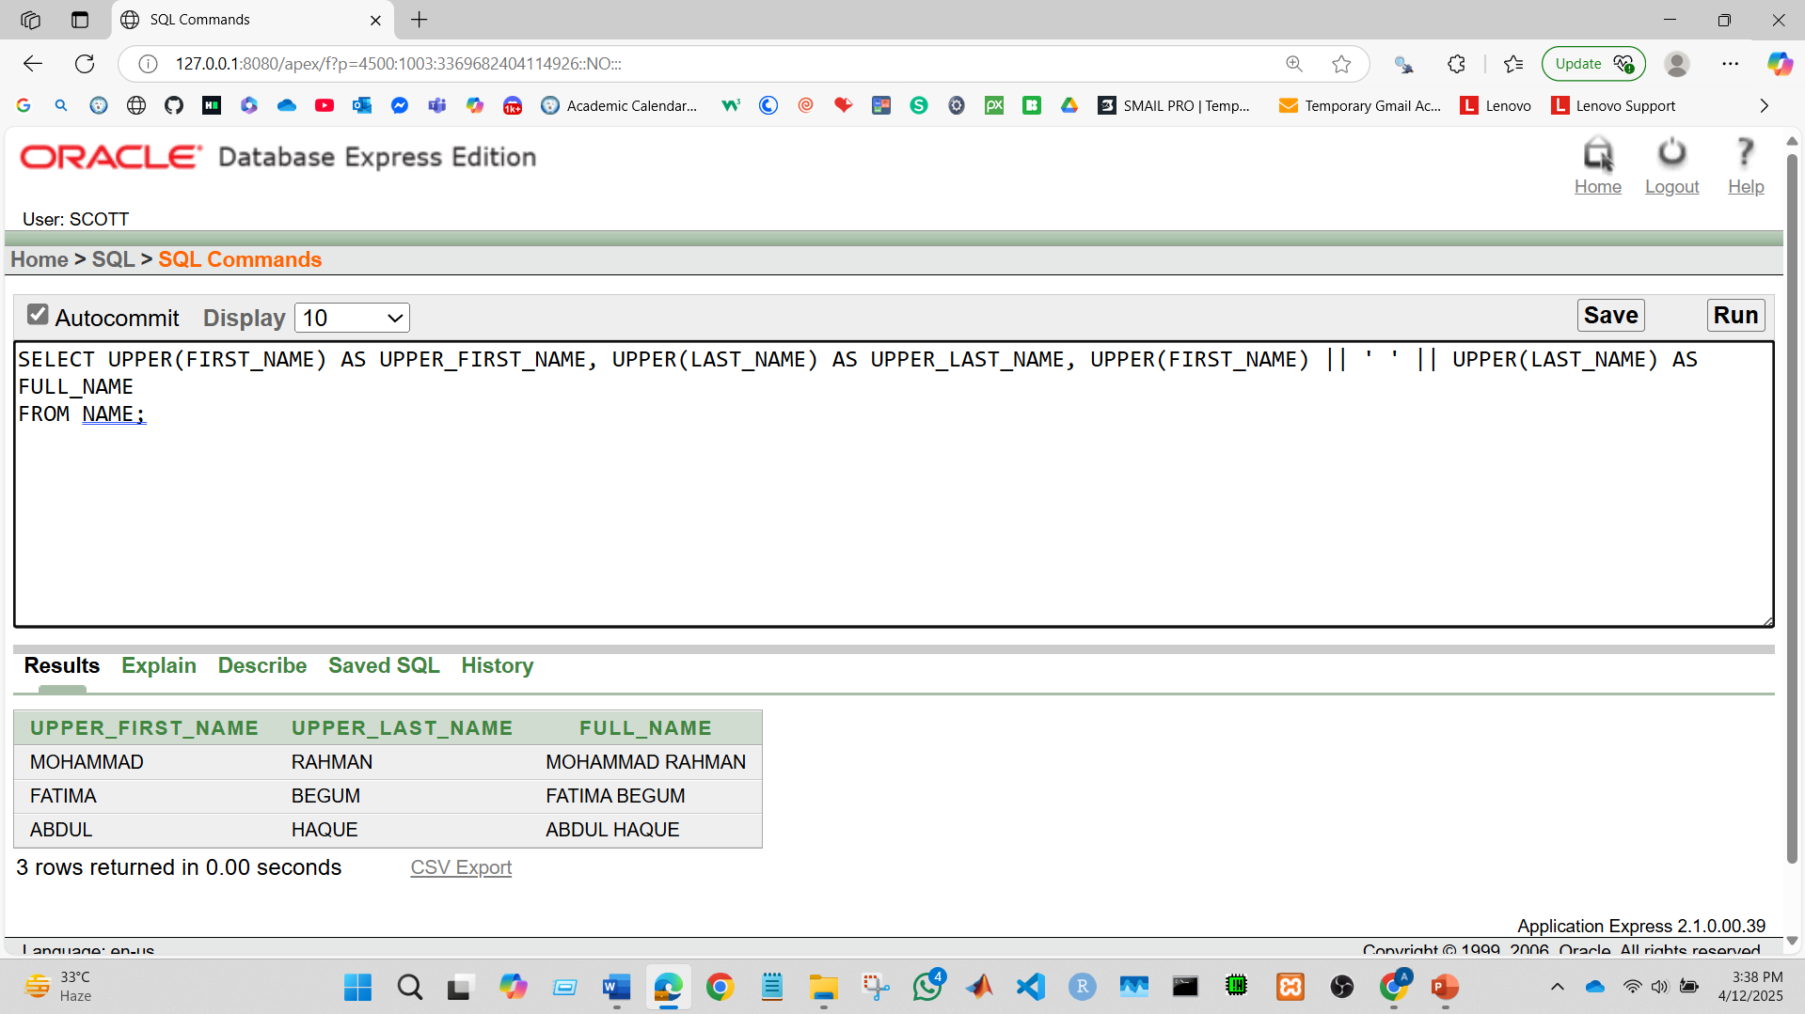

Q2. Display each bus model length.
Query:
SELECT BUS_NUMBER, LENGTH(MODEL) AS MODEL_LENGTH
FROM BUS;
Output Screenshot:
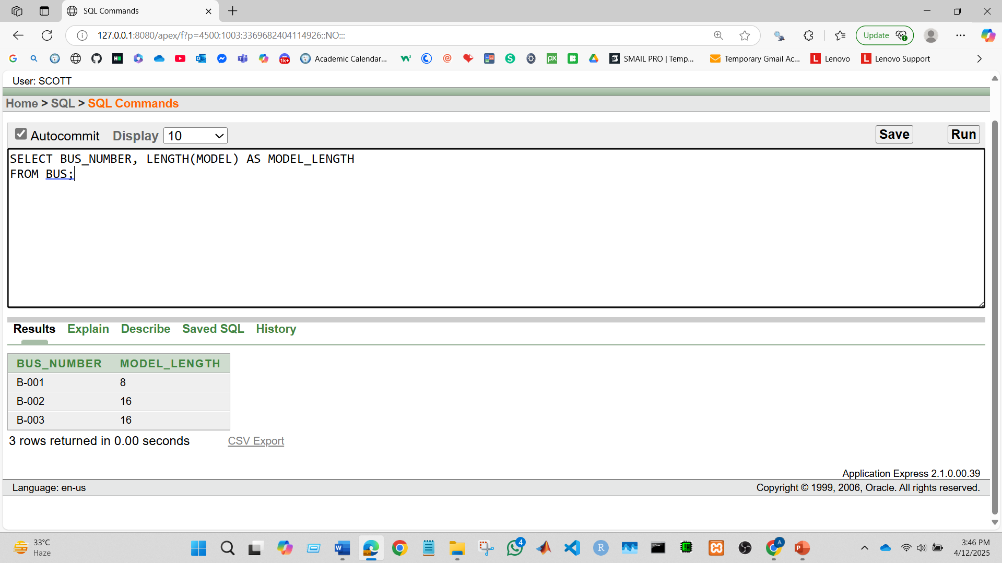

Group Function
Q1. Show the passenger’s count
Query:
SELECT COUNT(*) AS TOTAL_PASSENGERS
FROM PASSENGER;

Output Screenshot:
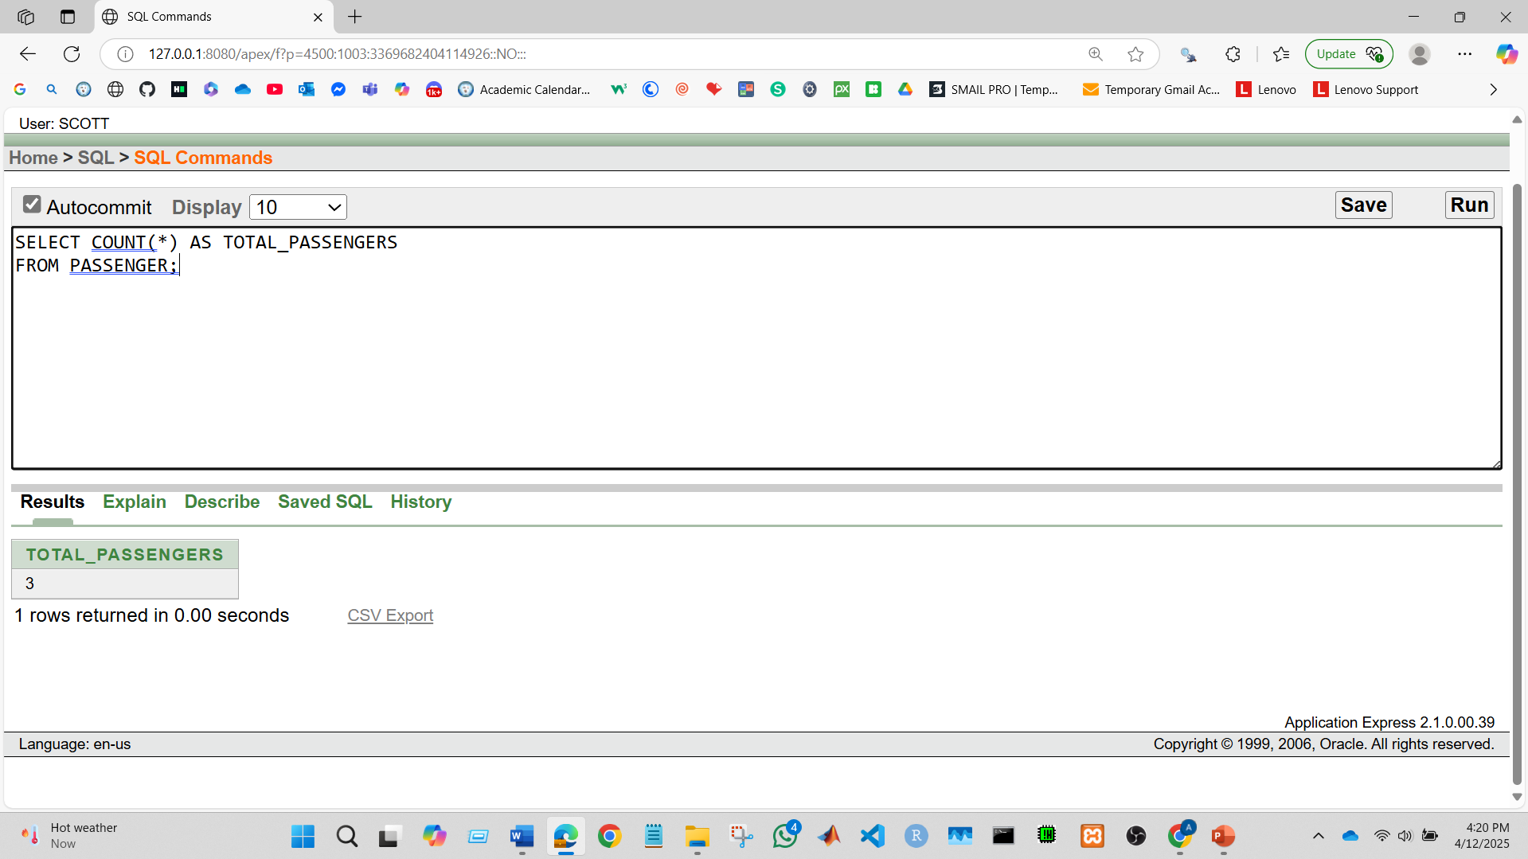
Q2. Display the average experience year of the supervisors.
Query:
SELECT AVG(EXPERIENCE_YEAR) AS AVERAGE_EXPERIENCE
FROM SUPERVISOR;
Output Screenshot:
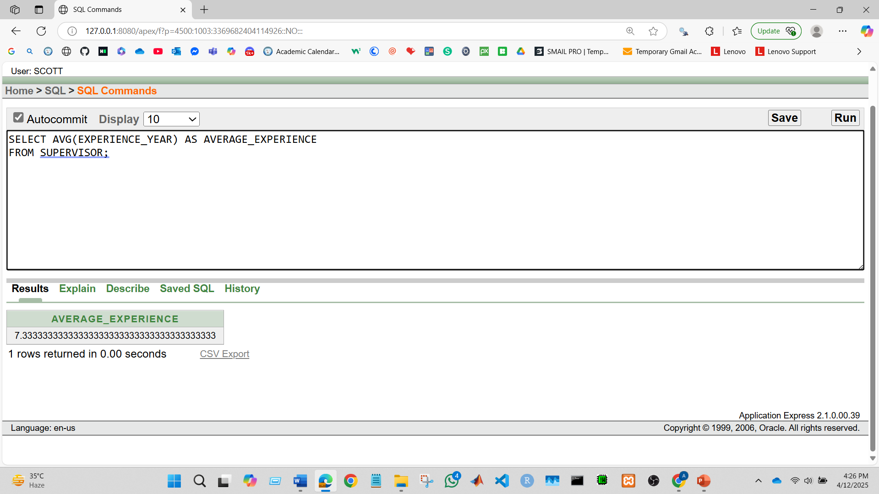

Subquery
Q1. Display the passengers Full Name who have booked a ticket?
Query:
SELECT FIRST_NAME || ' ' || LAST_NAME AS FULL_NAME
FROM NAME
WHERE NAME_ID IN (
SELECT NAME_ID
FROM PASSENGER
WHERE NATIONAL_ID IN (
SELECT NATIONAL_ID
FROM TICKET
WHERE TICKET_STATUS = 'Booked'
)
);
Output Screenshot:
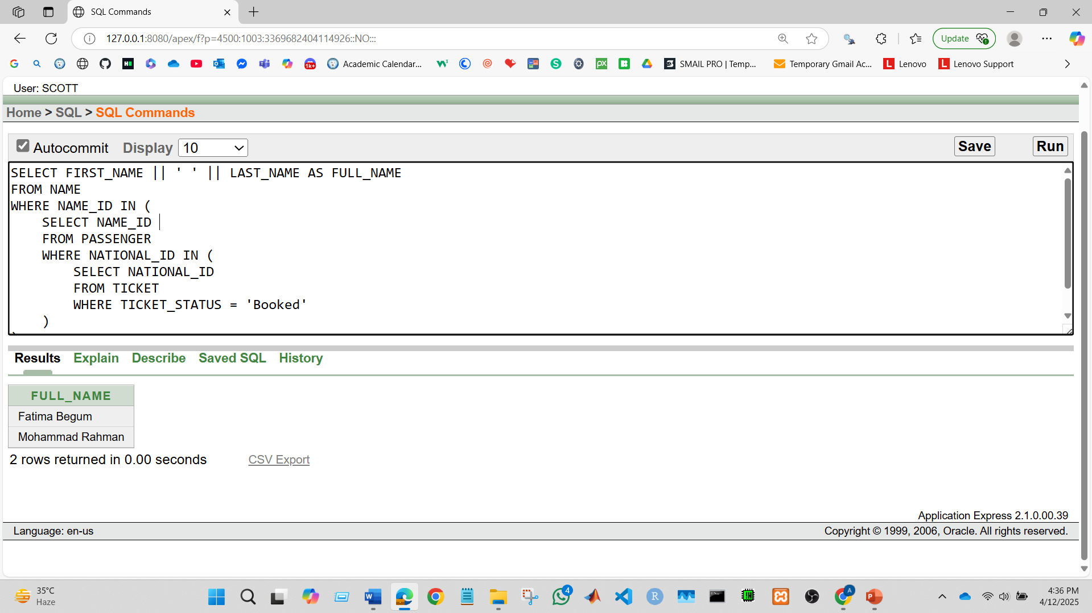

Q2. Display the Bus details which has maximum capacity.
Query:
SELECT *
FROM BUS
WHERE CAPACITY = (SELECT MAX(CAPACITY) FROM BUS);
Output Screenshot:
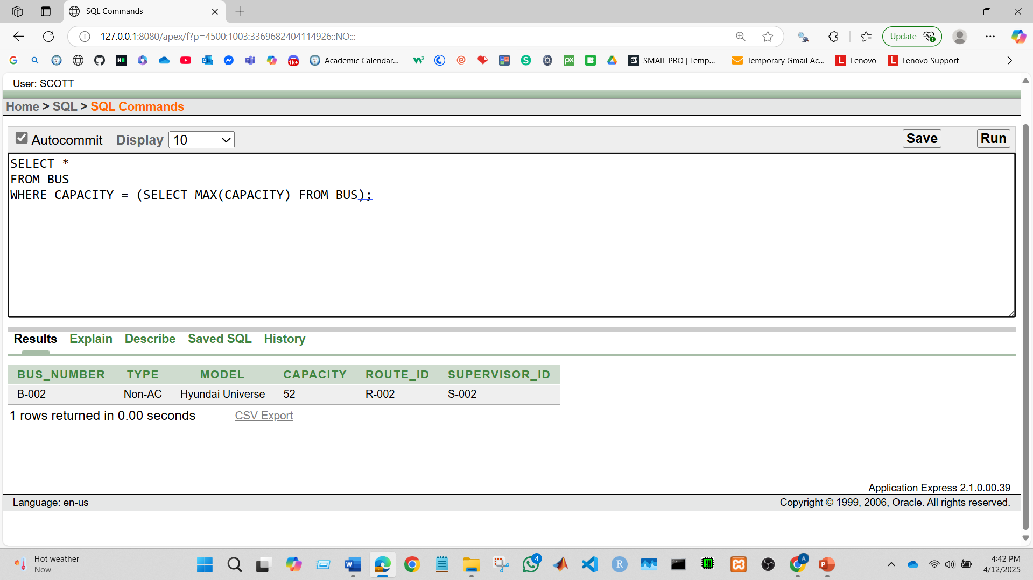

Joining
Q1. Display the list of all tickets along with passenger names and bus details.
Query:
SELECT T.TICKET_NUMBER, N.FIRST_NAME, N.LAST_NAME, B.BUS_NUMBER, T.TICKET_PRICE
FROM TICKET T, PASSENGER P, NAME N, BUS B
WHERE T.NATIONAL_ID = P.NATIONAL_ID
AND P.NAME_ID = N.NAME_ID
AND T.BUS_NUMBER = B.BUS_NUMBER;
Output Screenshot:
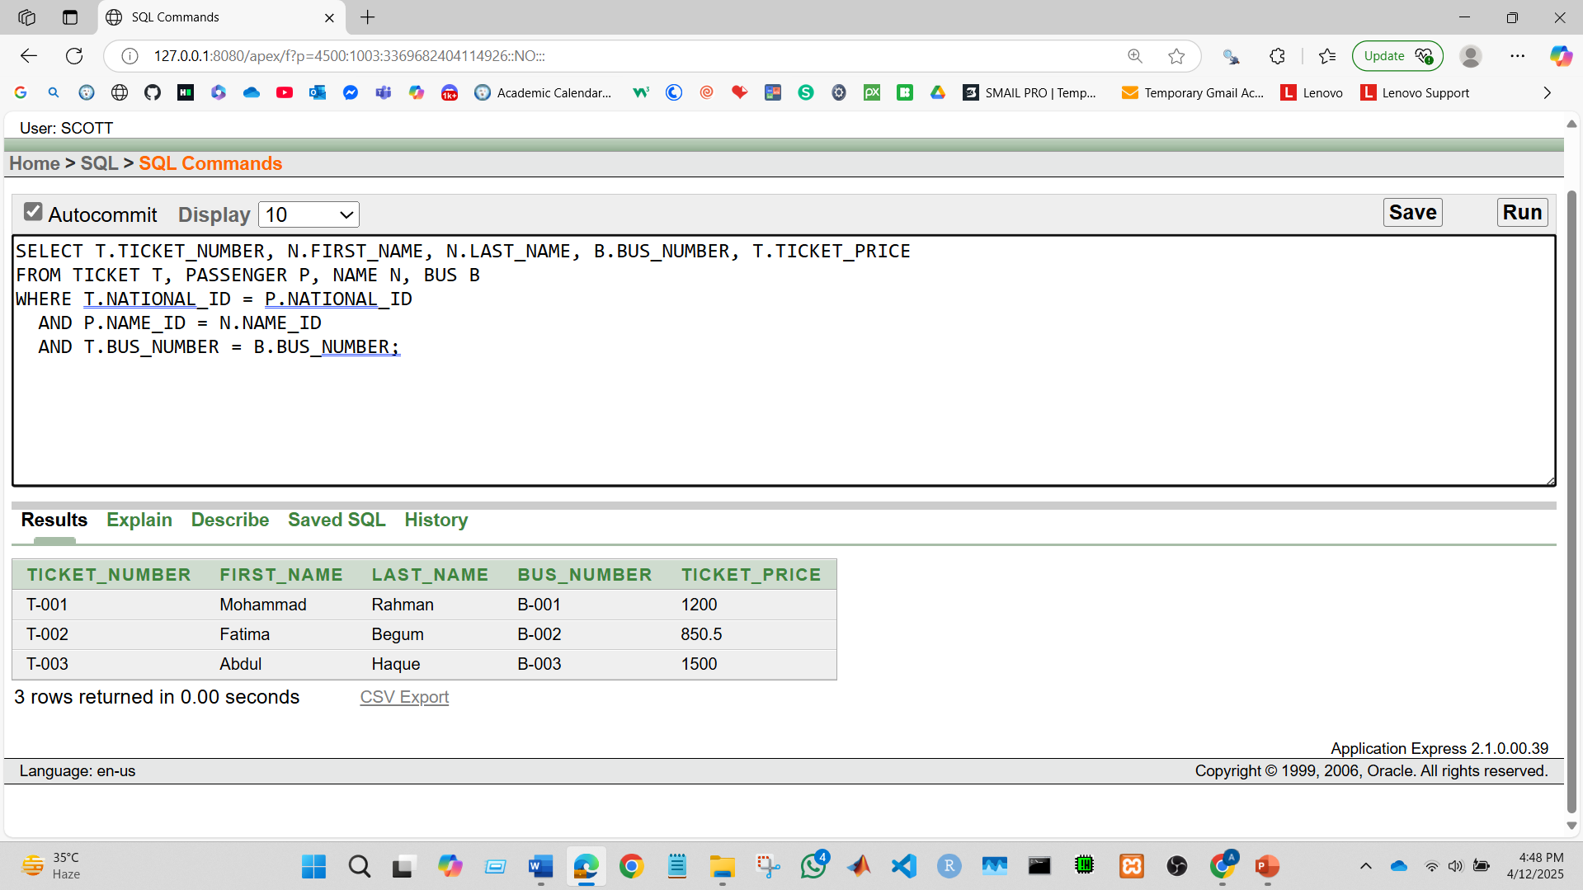

Q2. Show each bus, bus number, route ID, and the first and last name of its supervisor.
Query:
SELECT B.BUS_NUMBER, B.ROUTE_ID, N.FIRST_NAME, N.LAST_NAME
FROM BUS B, SUPERVISOR S, NAME N
WHERE B.SUPERVISOR_ID = S.SUPERVISOR_ID
AND S.NAME_ID = N.NAME_ID;
Output Screenshot:


